Ejercicio 2

|  |  |  |  |  |
| --- | --- | --- | --- | --- |
| **Orden que toma el Vértice** | **Vértices** | **Distancia (2,v)** | **Vértice Previo** | **Visitado** |
| 6° | 1 | ~~∞~~ ~~10~~ 8 | ~~2~~ 9 | ~~0~~ 1 |
| 1° | 2 | - | - | 1 |
| 3° | 3 | ~~∞~~ ~~6~~ 4 | ~~2~~ 7 | ~~0~~ 1 |
| 4° | 4 | ~~∞~~ ~~12~~ 9 | ~~7~~ 3 | ~~0~~ 1 |
| 7° | 5 | ~~∞~~ ~~11~~ 10 | ~~3~~ 1 | ~~0~~ 1 |
| 8° | 6 | ~~∞~~ ~~12~~ 11 | ~~4~~ 9 | ~~0~~ 1 |
| 2° | 7 | ~~∞~~ 2 | 2 | ~~0~~ 1 |
| 9° | 8 | ~~∞~~ ~~13~~ ~~12~~ 11 | ~~2~~ ~~3~~ 5 | ~~0~~ 1 |
| 5° | 9 | ~~∞~~ 7 | 7 | ~~0~~ 1 |

Ejercicio 3

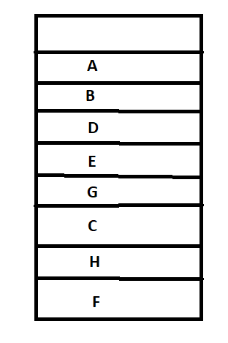

Desapilando la pila quedaría: A B D E G C H F